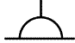 | Socket-outlet, general symbol
 | Twin Socket-outlet, general symbol
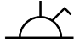 | Switched socket-outlet
 | Twin Switched socket-outlet
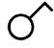 | Switch, general symbol
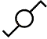 | 2 way switch, single pole
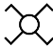 | Intermediate switch
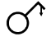 | Pull switch, single-pole

